**SYSTEM BOUNDARIES**

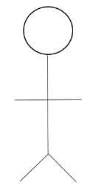

User

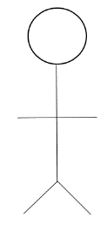

Hospital

**SYSTEM BOUNDARIES**

User

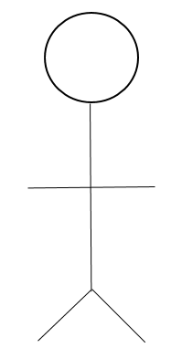

  

Old New Operator